**Flask 1**

**Data Science Master’s Assignment**

**19th Feb. 2023**

**Q1. What is Flask Framework? What are the advantages of Flask Framework?**

**Sol. Flask** is a micro web framework written in Python. It is classified as a micro framework because it does not require particular tools or libraries. It has no database abstraction layer, form validation, or any other components where pre-existing third-party libraries provide common functions.

Advantages of FlaskFramework,

#### Scalable

#### Flexible

#### Easy to negotiate

#### Lightweight

**Q2. Create a simple Flask application to display ‘Hello World!!’. Attach the screenshot of the output in Jupyter Notebook.**

**Sol.**

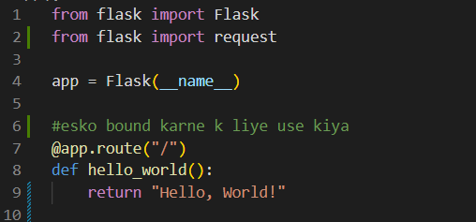

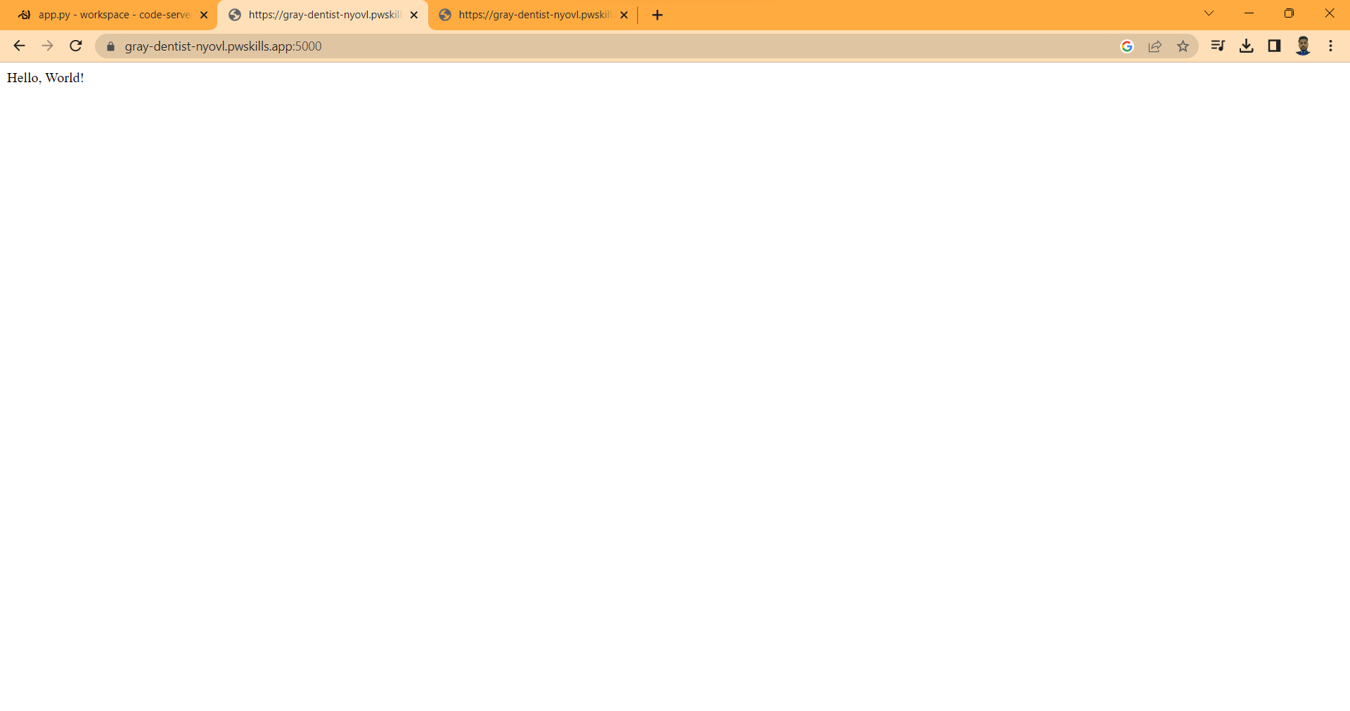

**Q3. What is App routing in Flask? Why do we use app routes?**

**Sol.** App routing is the technique used to map the specific URL with the associated function intended to perform some task. The Latest Web frameworks use the routing technique to help users remember application URLs.

App routing is used to map the specific URL with the associated function that is intended to perform some task. It is used to access some particular page like Flask Tutorial in the web application.

In our first application, the URL ('/') is associated with the home function that returns a particular string displayed on the web page.

Q4. **Create a “/welcome” route to display the welcome message “Welcome to ABC Corporation” and a “/” route to show the following details:**

**Company Name: ABC Corporation**

**Location: India**

**Contact Detail: 999-999-9999**

**Attach the screenshot of the output in Jupyter Notebook.**

**Sol.**

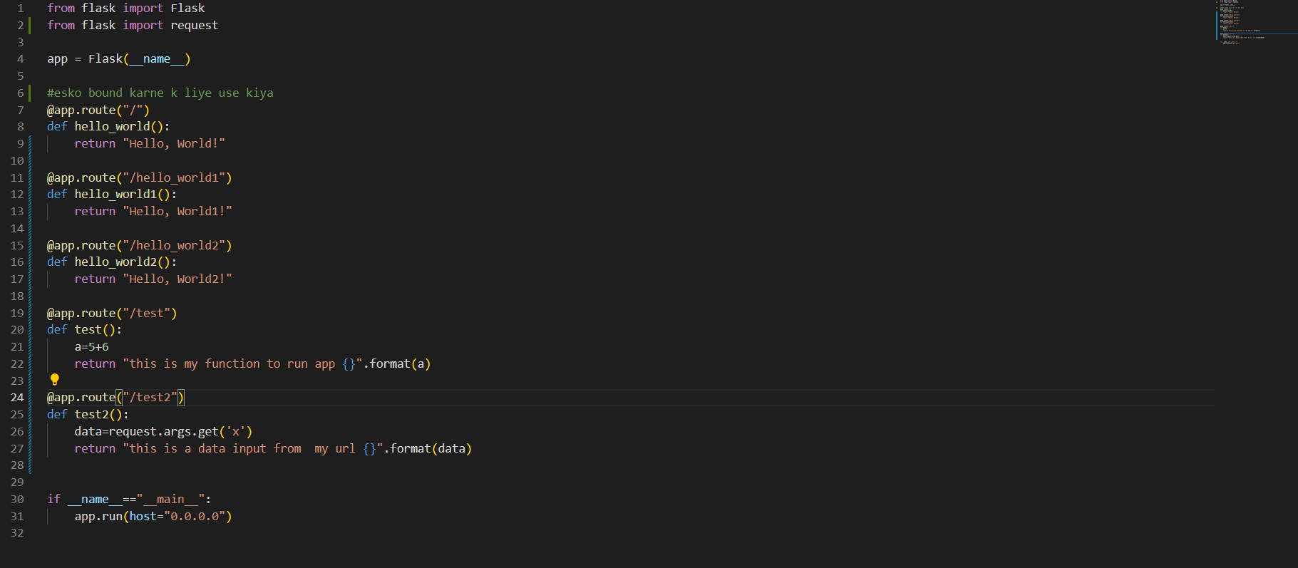

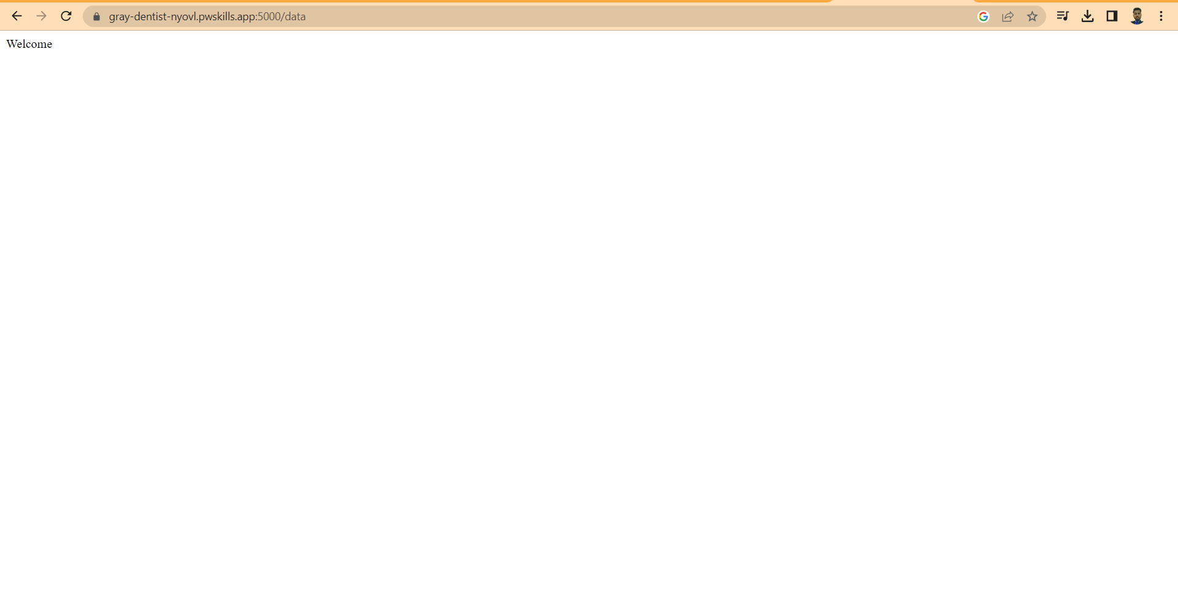

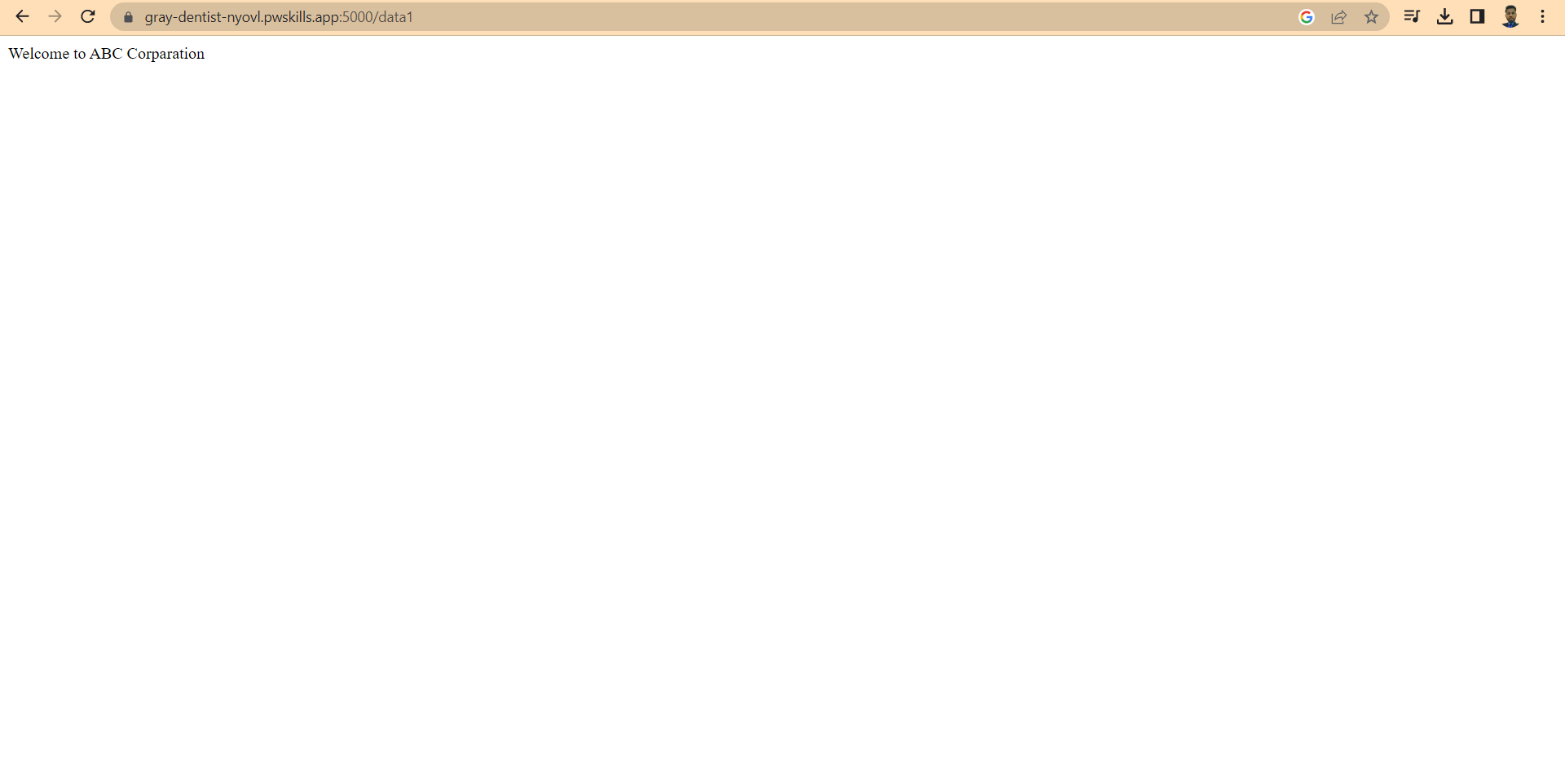

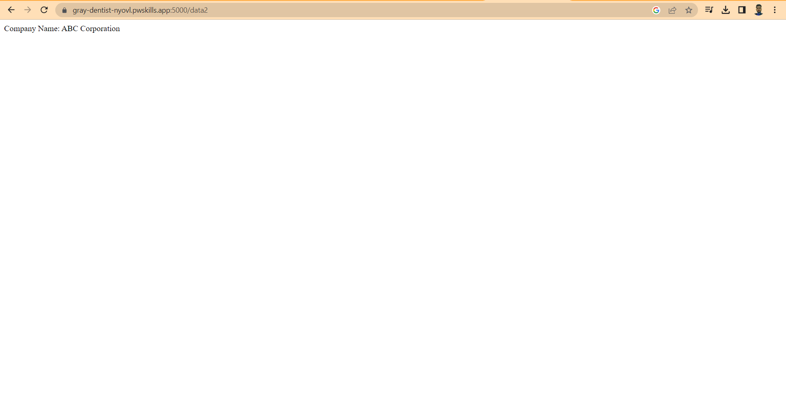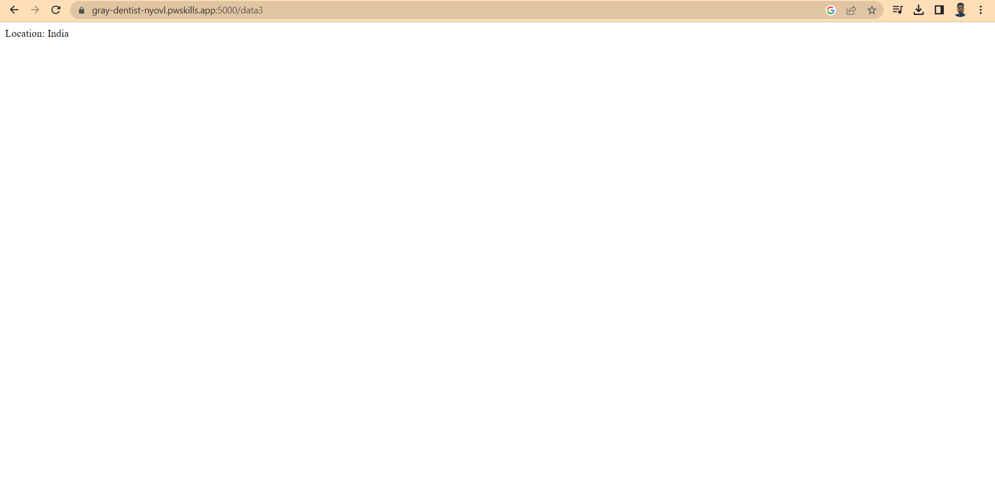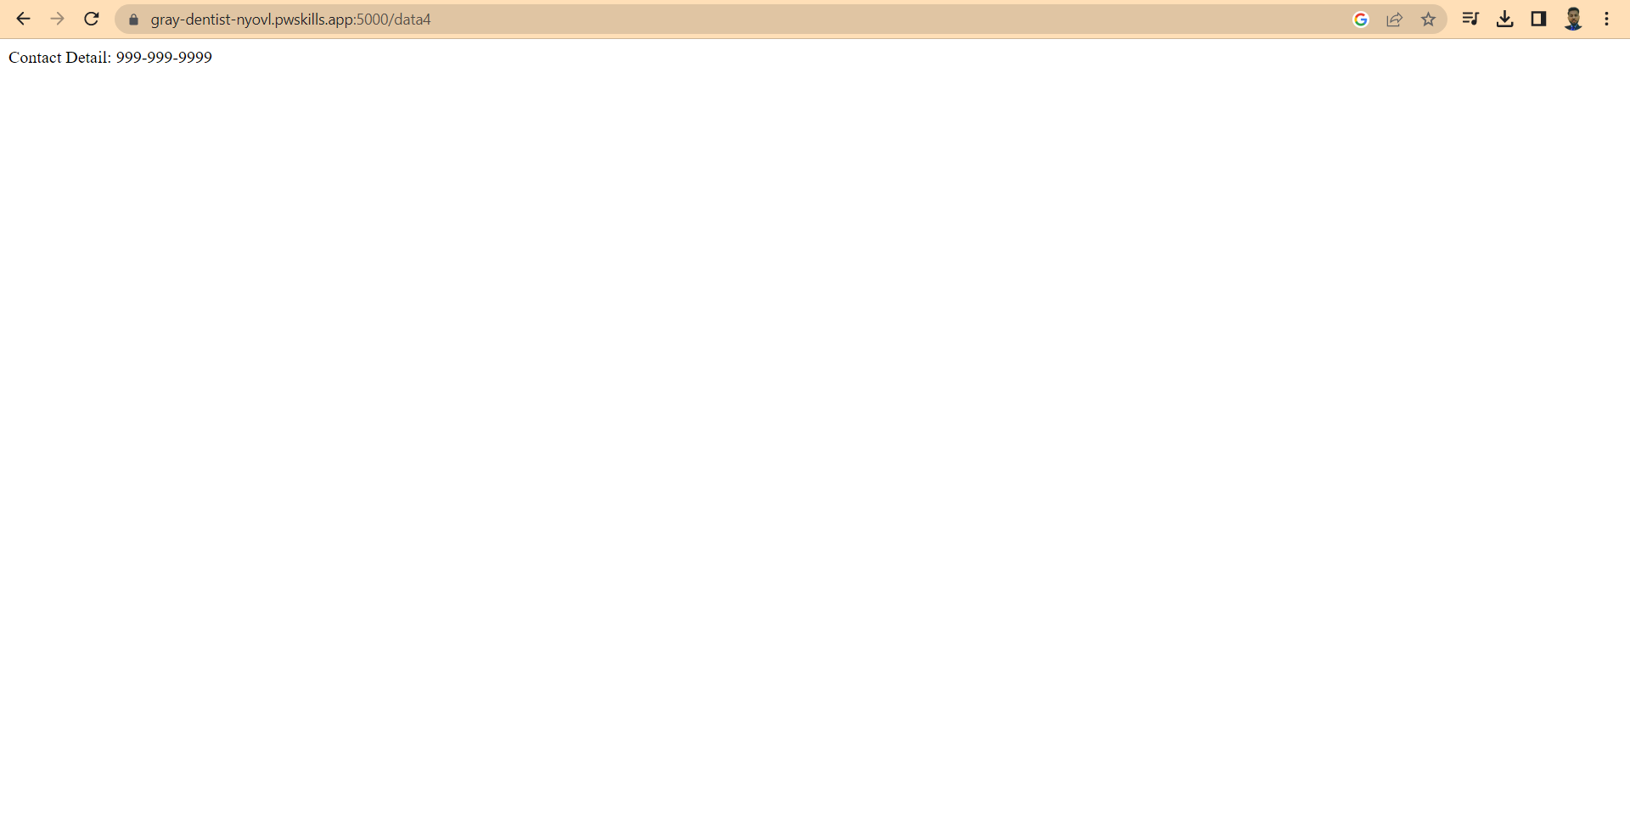

Q5. What function is used in Flask for URL Building

Sol. The url_for() function is used to build a URL to the specific function dynamically. The first argument is the name of the specified function, and then we can pass any number of keyword argument corresponding to the variable part of the URL.

This function is useful in the sense that we can avoid hard-coding the URLs into the templates by dynamically building them using this function.